**A Project Report**

**On**

**“JCONNECTS”**

Submitted by:

Name : ELISA A THOMAS

Reg no : 18MEC24036

**Under the Guidance of:**

Prof. Shashikala

And

Prof. Nitya

Department of Computer Science

**05/ 12/ 2020**



**Department of Computer Science**

**St. Joseph’s College (Autonomous)**

**Bengaluru**

**Certificate**



This to certify that ELISA A THOMAS (18MEC24036) have successfully completed the project titled “JCONNECTS” at St. Joseph’s College (Autonomous) under the supervision and guidance in the fulfilment of requirements of Fifth semester, Bachelor of Science (Computer Science) of Bengaluru City University, Bengaluru.

1. Prof .Shashikala
2. Prof. Nitya

Prof. Sandhya

Head of the Department Computer Science

Personal Details Of Project Members

|  |  |
| --- | --- |
| Student Name | Elisa A Thomas |
| Register Number | 18MEC24036 |
| College | St. Joseph’s College |
| Contact Number | +91 7892129683 |

|  |  |
| --- | --- |
| Student Name | Ayush Subramanyam Nayak |
| Register Number | 18MEC24037 |
| College | St. Joseph’s College |
| Contact Number | +91 8660780077 |

|  |  |
| --- | --- |
| Student Name | Prathiksha A |
| Register Number | 18MEC24031 |
| College | St. Joseph’s College |
| Contact Number | +91 8310817140 |

|  |  |
| --- | --- |
| Student Name | Sumit Patel |
| Register Number | 18MEC24004 |
| College | St. Joseph’s College |
| Contact Number | +91 7310481911 |

ACKNOWLEDGEMENT

The mini project titled “JCONNECTS” has been a keen interest of our team.

we have completed the project under the guidance and supervision of XXX, I received an esteemed scholarly guidance and assistance towards the fruitful completion of this website. We thank all the people who helped us to do this project. Special thanks to COMPUTER DEPARTMENT OF ST. JOSEPH’s COLLEGE for making the mini project possible.

CONTENTS

* Synopsis
* Abstract
* Introduction
* Study of proposed system
* System Requirements(Hardware and Software)
* Website Navigation Flow Chart
* Design of the website
* Coding of the website
* Future Enhancement of the website
* Conclusion
* Bibliography

***SYNOPSIS***

**ABSTRACT**

Our project is based on making a new platform for the users of St.Joseph’s College (Autonomous) to know more about the events happening in college, so basically it’s a social gathering website. We are taking into consideration about the current situation and are trying to encourage the students to participate in the events being held in our college after the current situation ends with necessary precautions needed. This a new project which we are working on and hope to implement it with more user interface. We tried to design the website such that it will be really easy for the user to understand how the website works. We will try to communicate more with users such that they won’t have difficulty in using our website.

**INTRODUCTION**

1. PROBLEM DEFINITION:

So the problem we have now is that we are currently in a very difficult state mentally and physically, we are really exhausted and scared because of the global way of life , enjoying life again after being locked up for a long time ,by keeping in mind to follow social distancing.

1. SCOPE OF THE SYSTEM:

The scope of our project is to try and give users the feel of normalcy, to feel save while joining events being held in our college and participate both on online as well as offline events being held. We are trying our best to provide our users the best.

1. OBJECTIVE:

Our main aim is to have active participation in events held in our college after the lockdown. We also plan on assuring the participants that full care is taken and social distancing will be maintained.

1. PRESENT SITUATION:

Since our situation is stable and we can go back to normalcy we plan on having safe events being held and also promote events which will have active participation.

1. PROJECT CATEGORY:

This is a web based project.

***Study of proposed system***

PROPOSED SYSTEM:

This is a software project which our team came up with when we thought about how can we participate and get information on the events happening in campus. So we came up with the idea of “JCONNECTS” we have just finished the frontend part of our mini project for now , in future we plan on implementing backend to our project work. We have used HTML, CSS , JAVASCRIPT and BOOTSTRAP for our frontend design.

FRONTEND

HTML:

Hypertext Markup Language (HTML) is the standard markup language for documents designed to be displayed in a web browser. It can be assisted by technologies such as Cascading Style Sheets (CSS) and scripting languages such as JavaScript.

Web browsers receive HTML documents from a web server or from local storage and render the documents into multimedia web pages. HTML describes the structure of a web page semantically and originally included cues for the appearance of the document.

HTML elements are the building blocks of HTML pages. With HTML constructs, images and other objects such as interactive forms may be embedded into the rendered page. HTML provides a means to create structured documents by denoting structural semantics for text such as headings, paragraphs, lists, links, quotes and other items. HTML elements are delineated by tags, written using angle brackets. Tags such as <img /> and <input /> directly introduce content into the page. Other tags such as <p> surround and provide information about document text and may include other tags as sub-elements. Browsers do not display the HTML tags, but use them to interpret the content of the page.

HTML can embed programs written in a scripting language such as JavaScript, which affects the behavior and content of web pages. Inclusion of CSS defines the look and layout of content. The World Wide Web Consortium (W3C), former maintainer of the HTML and current maintainer of the CSS standards, has encouraged the use of CSS over explicit presentational HTML since 1997.

CSS:

Cascading Style Sheets (CSS) is a style sheet language used for describing the presentation of a document written in a markup language such as HTML.CSS is a cornerstone technology of the World Wide Web, alongside HTML and JavaScript.

CSS is designed to enable the separation of presentation and content, including layout, colors, and fonts.This separation can improve content accessibility, provide more flexibility and control in the specification of presentation characteristics, enable multiple web pages to share formatting by specifying the relevant CSS in a separate .css file which reduces complexity and repetition in the structural content as well as enabling the .css file to be cached to improve the page load speed between the pages that share the file and its formatting.

Separation of formatting and content also makes it feasible to present the same markup page in different styles for different rendering methods, such as on-screen, in print, by voice (via speech-based browser or screen reader), and on Braille-based tactile devices. CSS also has rules for alternate formatting if the content is accessed on a mobile device.

JAVA SCRIPT:

JavaScript often abbreviated as JS, is a programming language that conforms to the ECMAScript specification.JavaScript is high-level, often just-in-time compiled, and multi-paradigm. It has curly-bracket syntax, dynamic typing, prototype-based object-orientation, and first-class functions.

Alongside HTML and CSS, JavaScript is one of the core technologies of the World Wide Web. JavaScript enables interactive web pages and is an essential part of web applications. The vast majority of websites use it for client-side page behavior, and all major web browsers have a dedicated JavaScript engine to execute it.

As a multi-paradigm language, JavaScript supports event-driven, functional, and imperative programming styles. It has application programming interfaces (APIs) for working with text, dates, regular expressions, standard data structures, and the Document Object Model (DOM). However, the language itself does not include any input/output (I/O), such as networking, storage, or graphics facilities, as the host environment (usually a web browser) provides those APIs.

JavaScript engines were originally used only in web browsers, but they are now embedded in some servers, usually via Node.js. They are also embedded in a variety of applications created with frameworks such as Electron and Cordova.

Although there are similarities between JavaScript and Java, including language name, syntax, and respective standard libraries, the two languages are distinct and differ greatly in design.

BOOTSTRAP:

Bootstrap is a free and open-source CSS framework directed at responsive, mobile-first front-end web development. It contains CSS- and (optionally) JavaScript-based design templates for typography, forms, buttons, navigation, and other interface components.

Bootstrap is the seventh-most-starred project on GitHub, with more than 142,000 stars, behind freeCodeCamp (almost 312,000 stars) and marginally behind Vue.js framework.

Modules and Functions:

HOMEPAGE MODULE:

This is the main module of the website and will be displayed on the website startup. This module contains header navigation bar which contains the logo and the buttons for the other pages included in the website.

It displays a brief description about the page, a slideshow and a video to make the site more attractive. We have also added a popup feedback button so that it will be easy for the user to give us any feedback which they might think that we can add to the website. We have also added a footer navigation bar so that the user need not have to keep scrolling up and down to keep moving to the next webpages.

LOGIN module:

In the login module we have two options one for user login and the other for admin login. For the user login we have also added a option for registration so that the new users can register and then login to know more about the website.

ABOUT US module:

This module gives a description on what we are doing and how we plan on executing it. We also want our users to have an active participation in what we are planning to do.

EVENTS module:

In this module we allow our users to post events on the website but the admin will be able to check and approve of which posts will be given more importance and can be posted on the website.

CONTACT US module:

In this module we give the users more information on different ways they can contact us not just through the website, if they want to know more or about any queries they can approach us through different social media platforms with their doubts regarding the events taking place or on how to post or why their post was not approved.

SHARE module:

In this module we plan on promoting our work through our users. We want more people to know that such a website exists to make their life more easier not just that they need not have to keep joining various whatsapp groups to know more about the evenst , they can just view it in the same place and also try to join other events which they might be interested in.

***System Requirements(Hardware and Software)***

Software requirements:

OPERATING SYSTEM: WINDOWNS 7-10

WEBSERVER: IIS4.0

BROWSER: INTERNET EXPLORER,CHROME,MORZILLA.

Hardware requirements:

PROCESSOR: INTEL CORE 13

RAM: 2GB

SYSTEM TYPE: 32/64BIT OS

***Website Navigation Flow Chart***

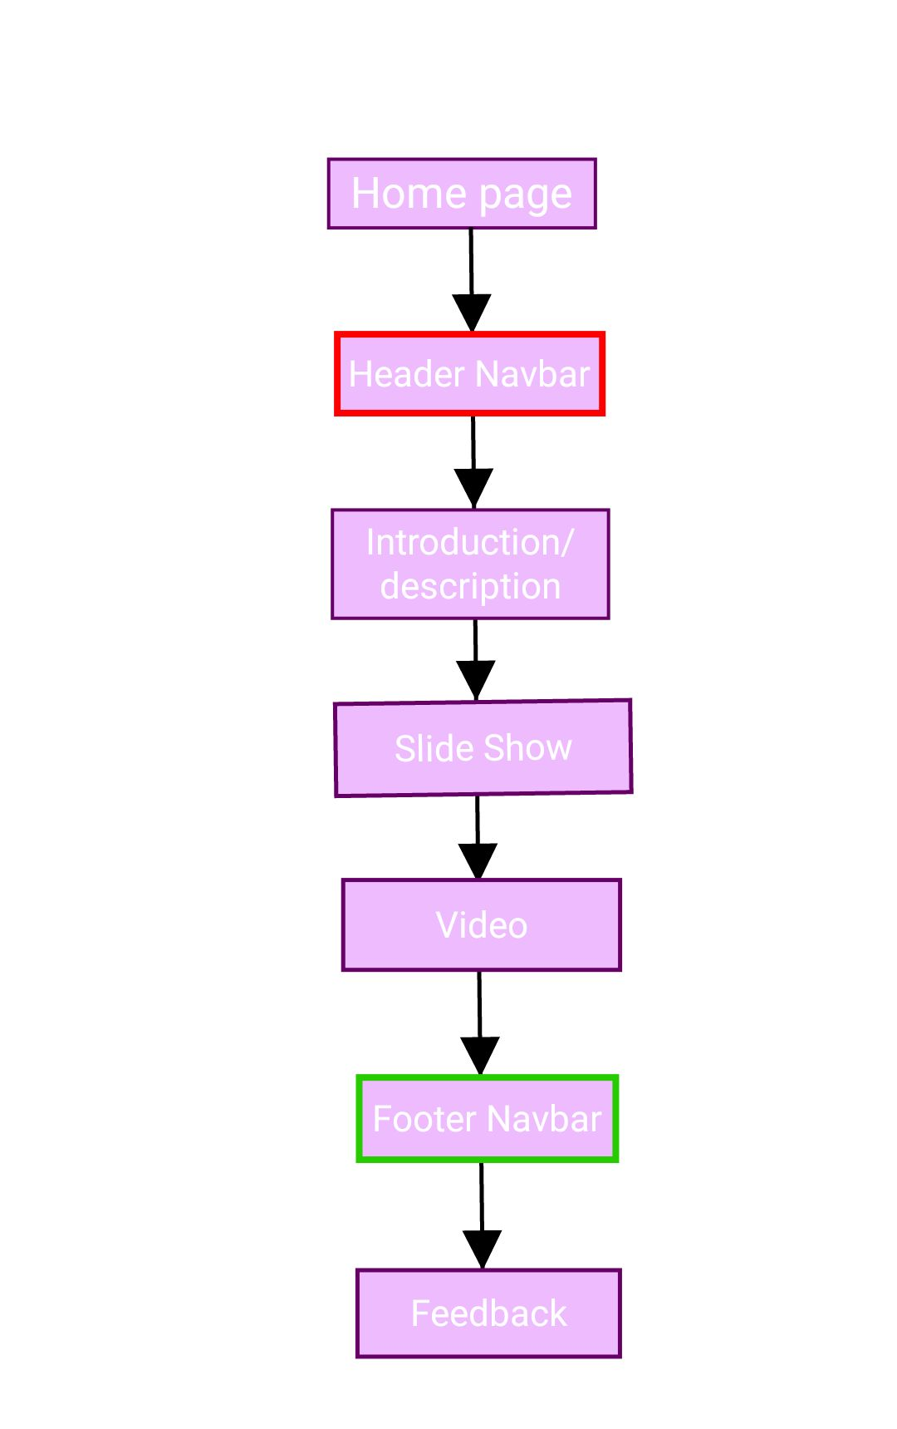 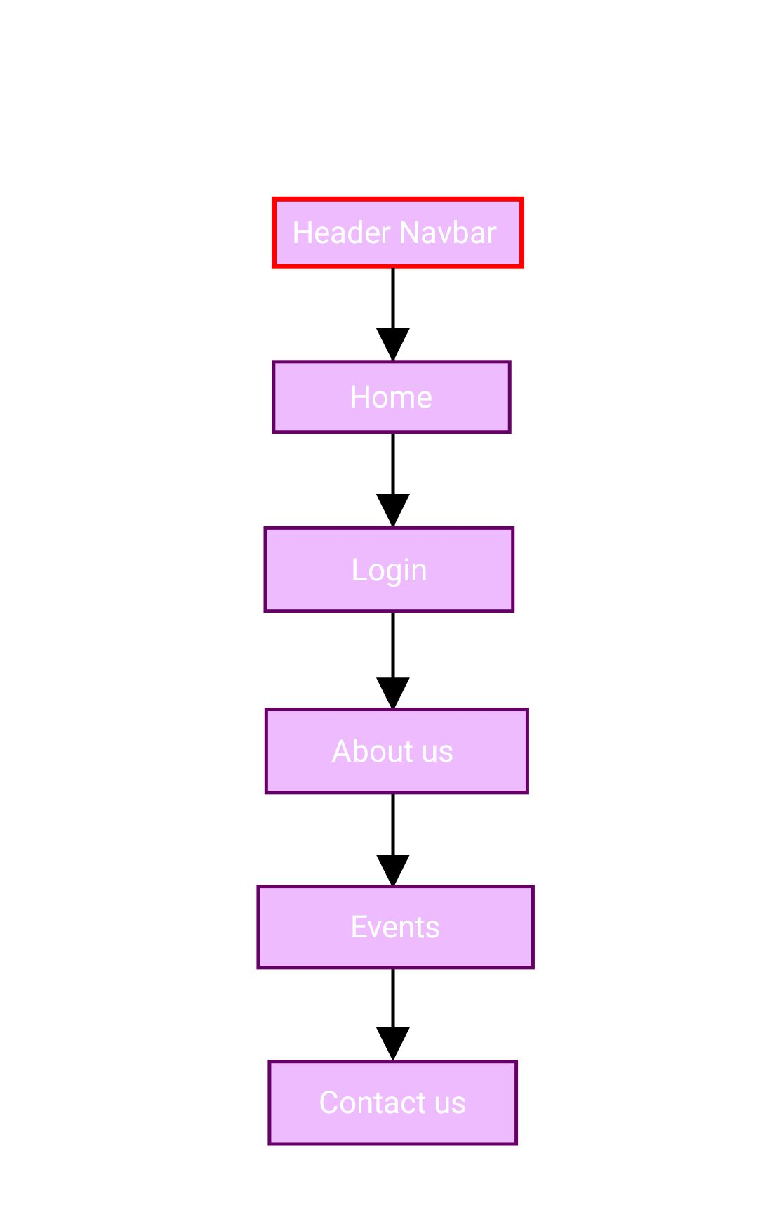 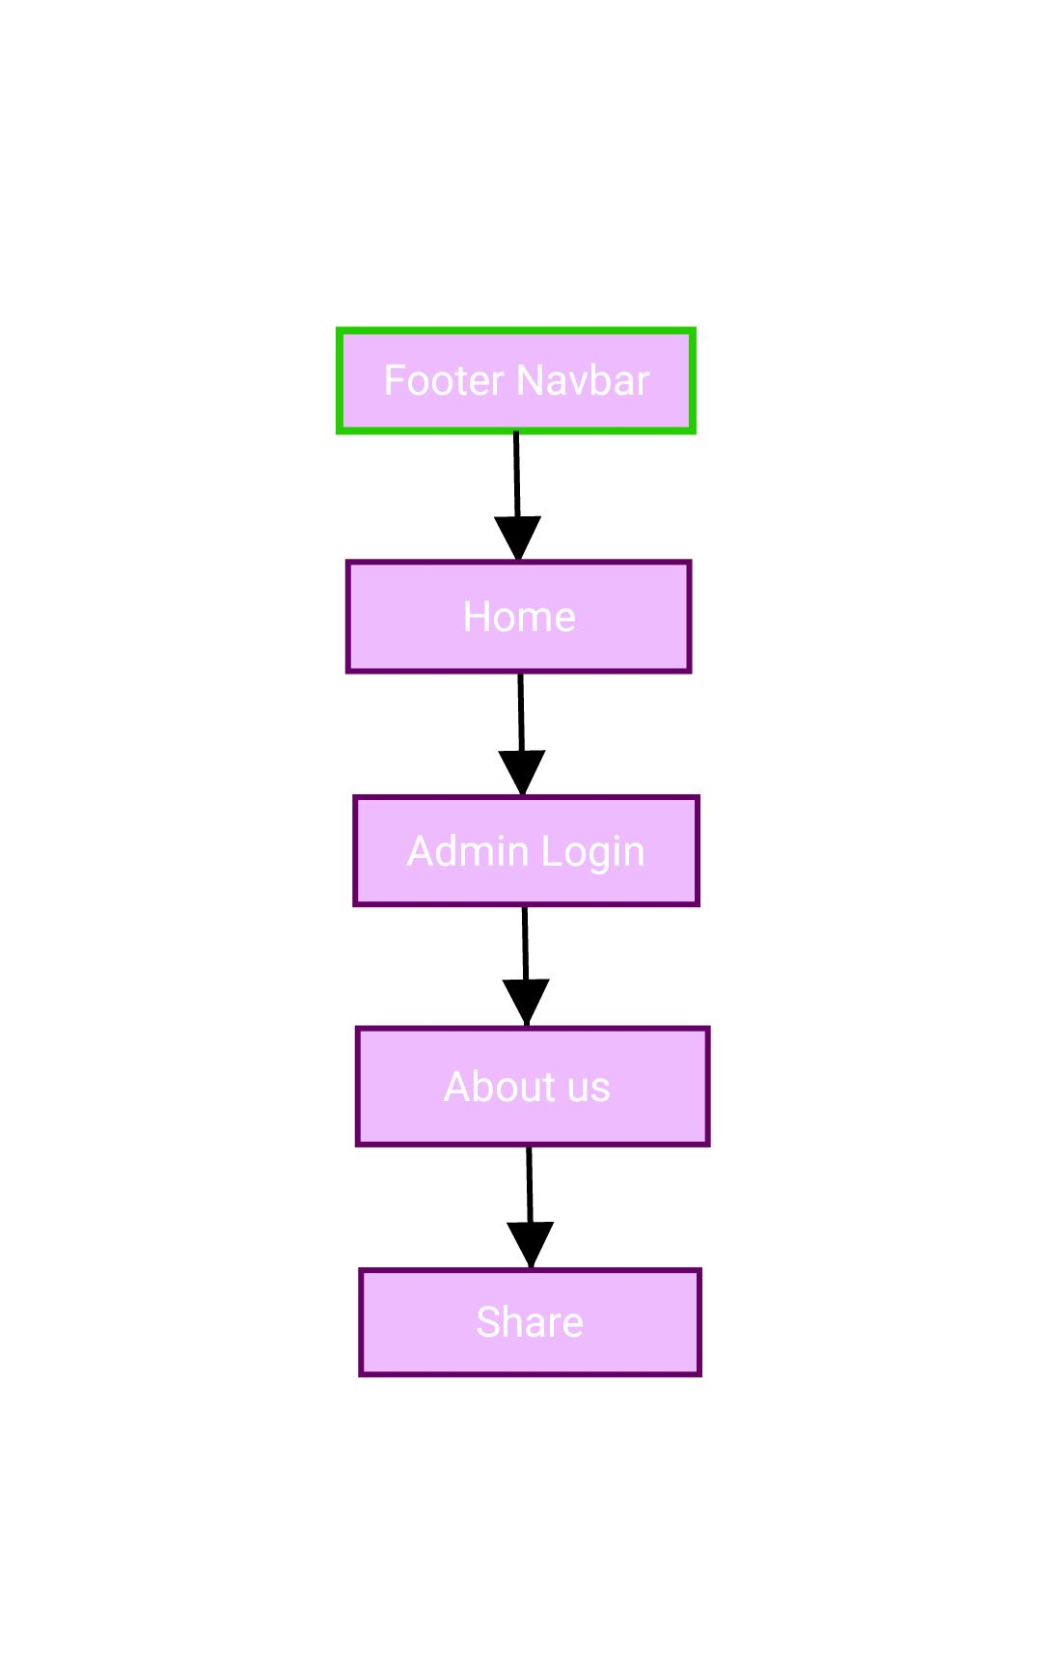

***Design of the website***

**Design :**

**We have designed the website such that it will be more user friendly and cut down their work while navigating through different pages. We have given buttons on each webpage that is connected to other webpages so that the user can just click on the button of the webpage he/she wants to see instead of going back and then navigating again. W e have also tried to keep each module simple such that the end user can be able to adjust with the website well.**

**MODULE:**

**1.Main page**

**2.Login page**

**3.About Us page**

**4.Events page**

**5.Contact us page**

**6.Feedback form**

**7.Share page**

**MAINPAGE**

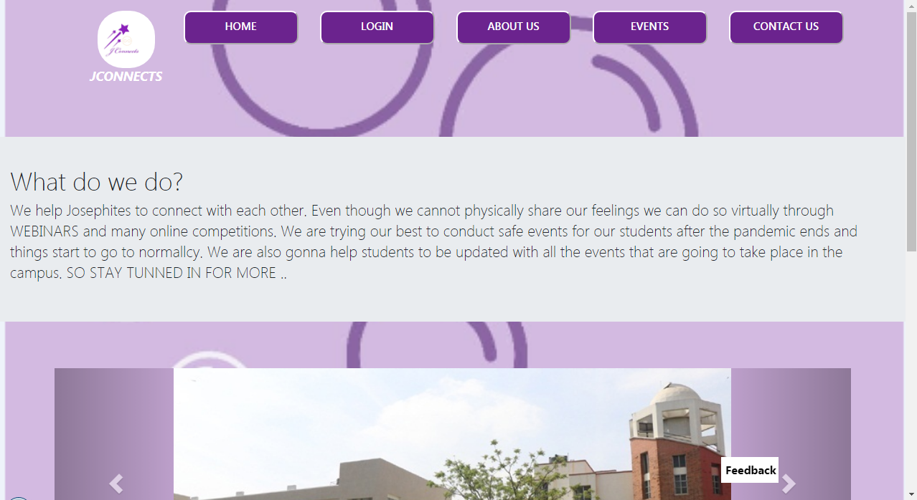

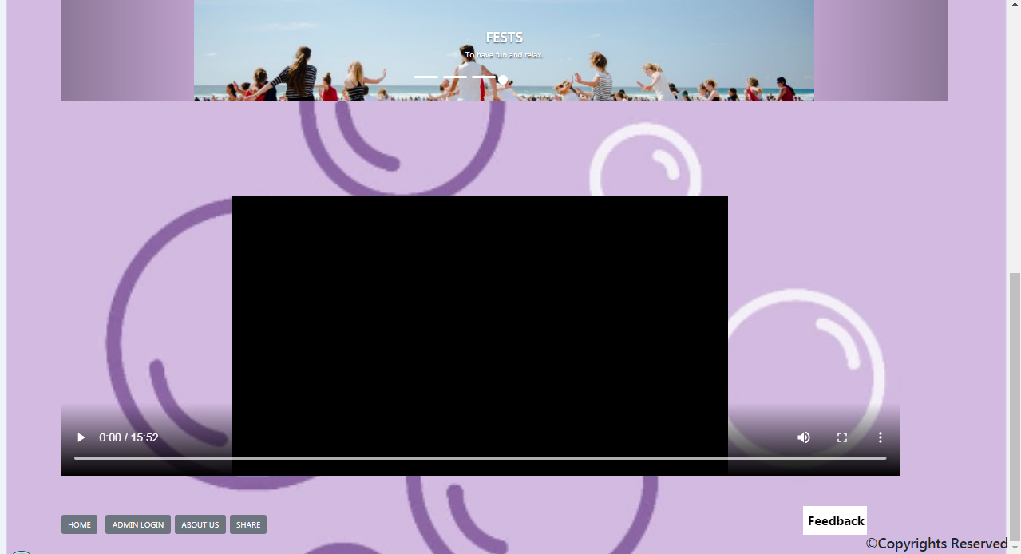

ON CLICKING FEEDBACK

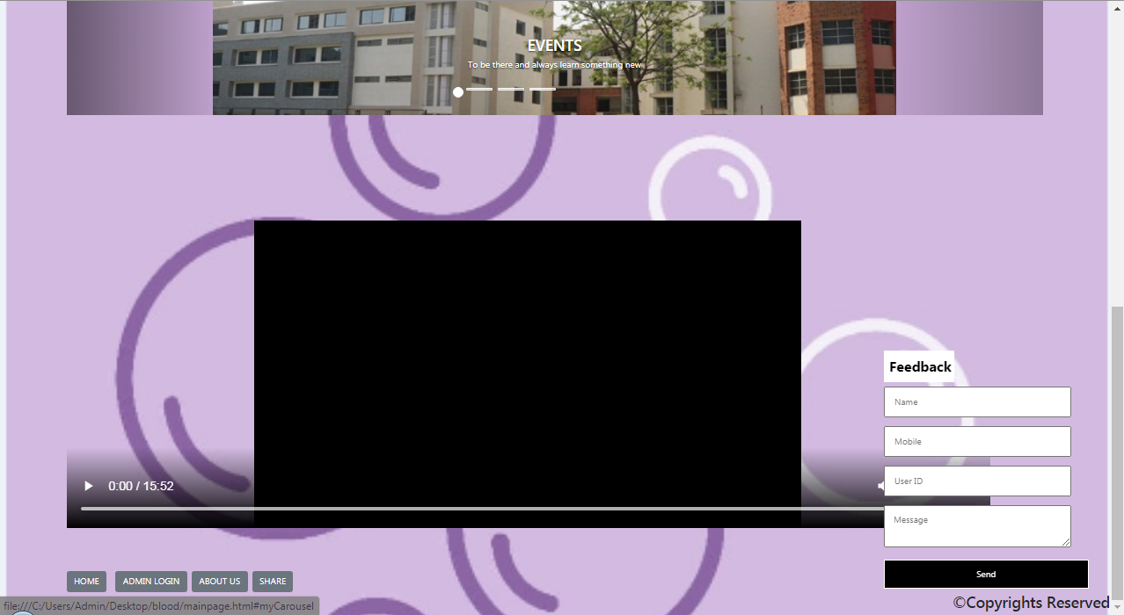

ON CLICKING LOGIN

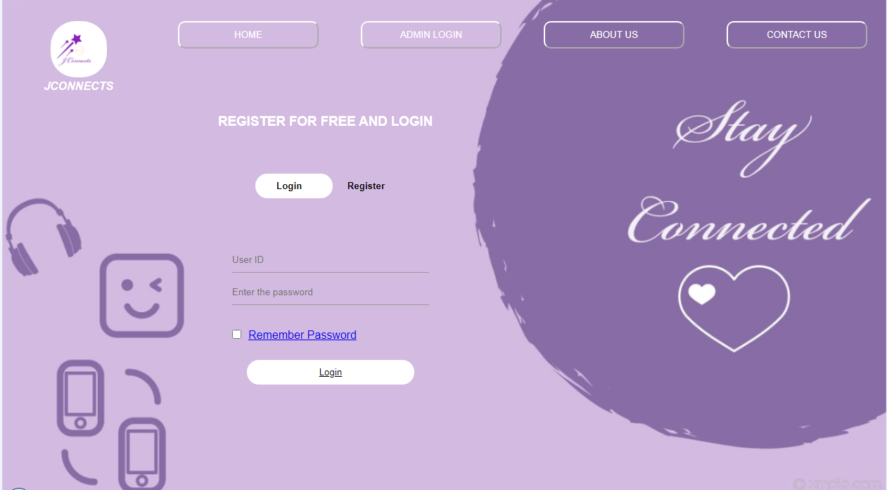

ON CLICKING REGISTER

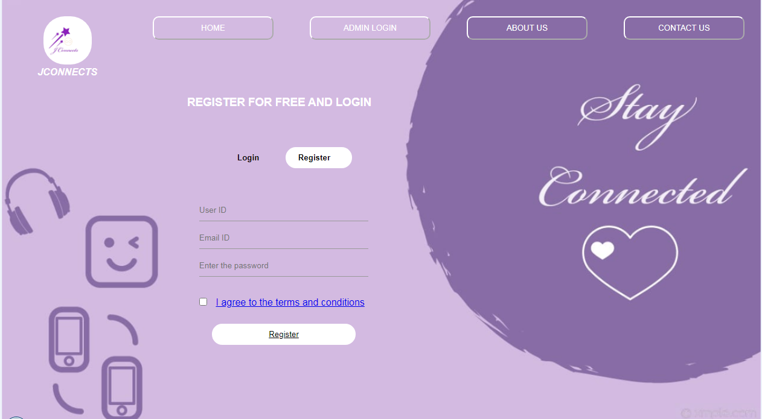

ON CLICKING ADMIN LOGIN

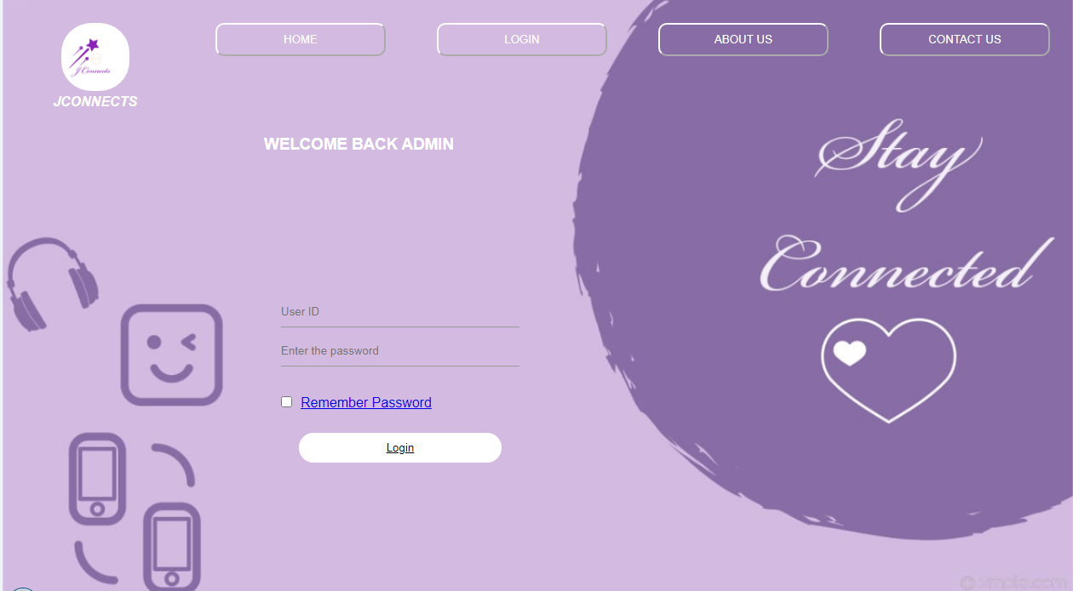

ON CLICKING ABOUT US

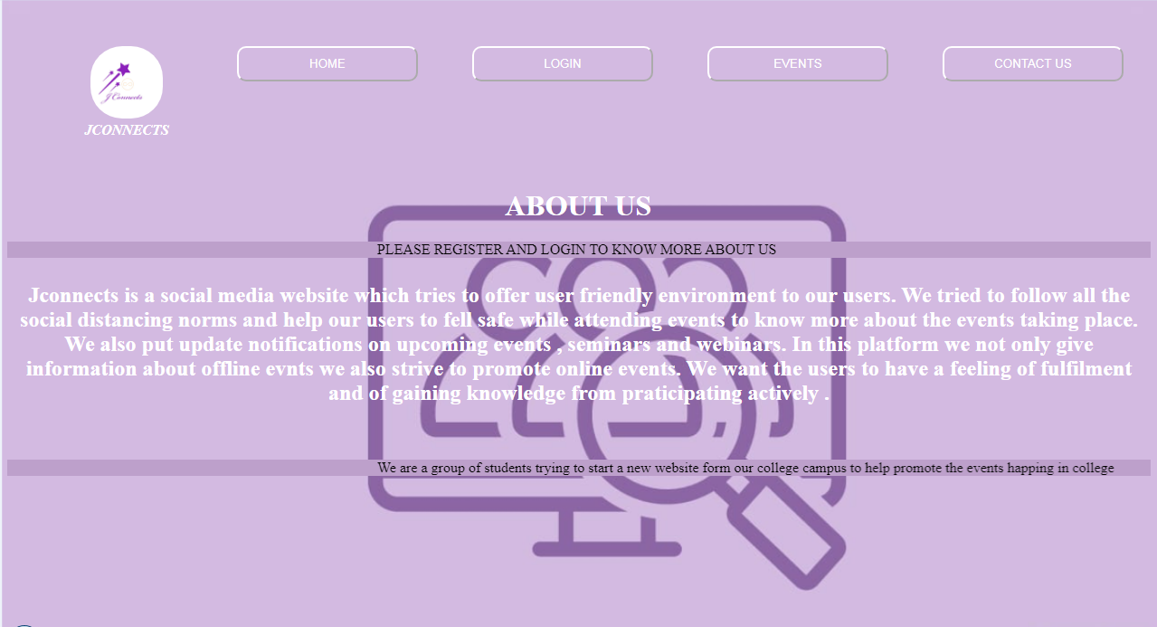

ON CLICKING CONTACT US

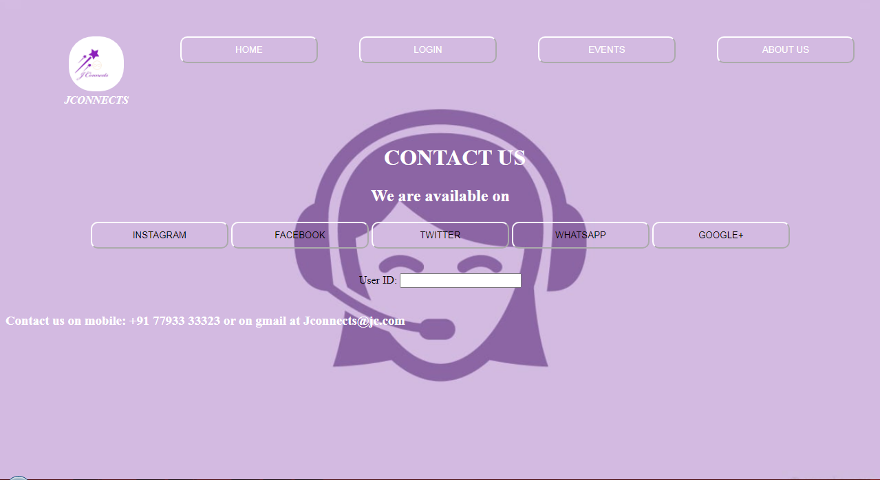

ON CLICKING EVENTS

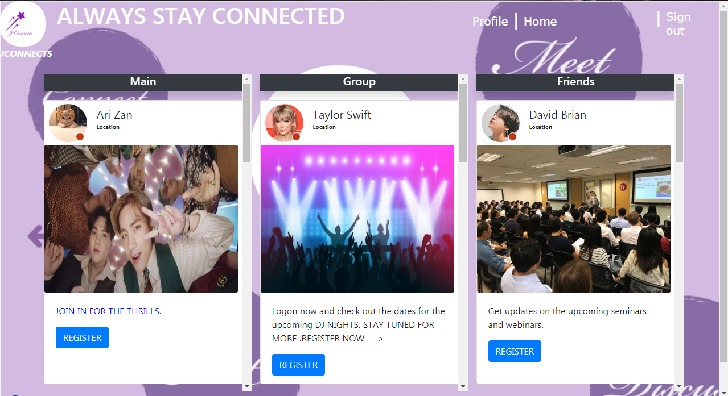

ON SCROLLING DOWN

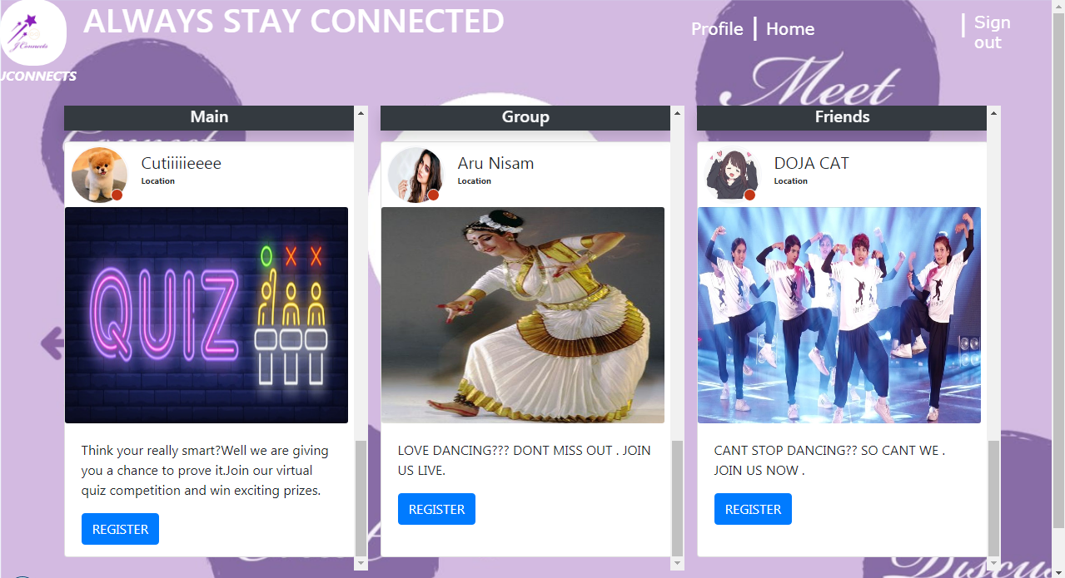

ON CLICKING SHARE

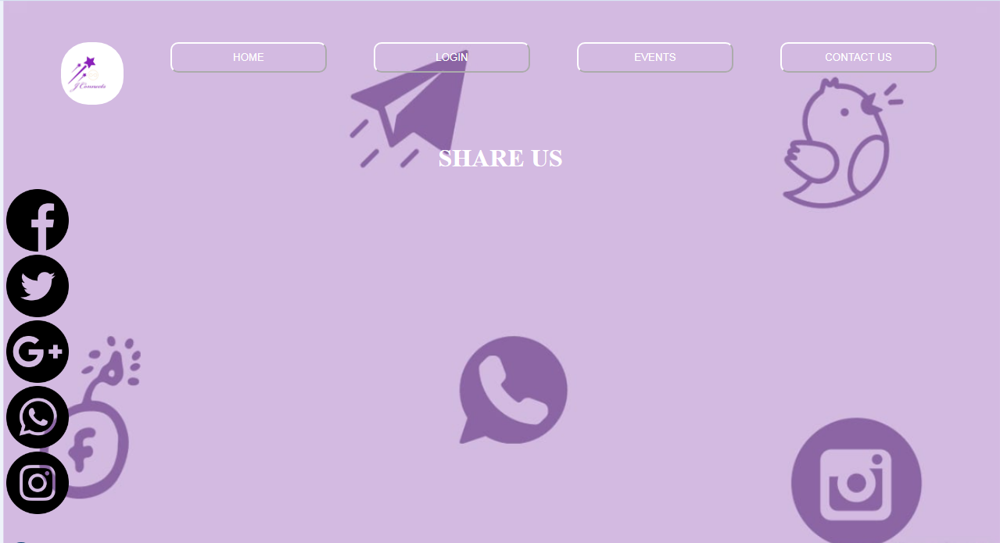

***Coding of the website***

Main page design:

The mainpage or the home page is the page which will be the first thing you will see when the project opens. The theme of our project is to connect and we wanted the website to be welcoming and warm, that is why we chose the color purple. We have the header navigation bar which will take you to the various modules which we want to display, we can see the introduction on “what we do ?”, there is also a slide show to attract the users attention and to show the various events taking place then we have a video which displays the college and the events taking place and at last we have the footer navigation bar which also takes you to different modules , we also have a feeback button.

<!DOCTYPE html>

<html lang="en">

<head>

<meta charset="utf-8">

<meta name="viewport" content="width=device-width, initial-scale=1">

<link rel="stylesheet" href="https://maxcdn.bootstrapcdn.com/bootstrap/3.3.7/css/bootstrap.min.css">

<script src="https://ajax.googleapis.com/ajax/libs/jquery/3.3.1/jquery.min.js"></script>

<script src="https://maxcdn.bootstrapcdn.com/bootstrap/3.3.7/js/bootstrap.min.js"></script>

<!-- Required meta tags -->

<meta charset="utf-8">

<meta name="viewport" content="width=device-width, initial-scale=1, shrink-to-fit=no">

<!-- Bootstrap CSS -->

<link rel="stylesheet" href="https://stackpath.bootstrapcdn.com/bootstrap/4.1.3/css/bootstrap.min.css" integrity="sha384-MCw98/SFnGE8fJT3GXwEOngsV7Zt27NXFoaoApmYm81iuXoPkFOJwJ8ERdknLPMO" crossorigin="anonymous">

<title>Welcome to Jconnects</title>

<script src="//platform-api.sharethis.com/js/sharethis.js#property=5b8bd4d15f7cb000119f5b01&product=inline-share-buttons"></script>

<style type="text/css">

@import url(http://weloveiconfonts.com/api/?family=entypo);

body{

background-image: url("main.png");

background-position: center;

background-size: cover;

background-repeat: no-repeat;

}

.menu-bar{

background-color: transparent;

text-align: center;

}

.menu-bar ul{

display: inline-flex;

list-style: none;

color: #fff;

}

.menu-bar ul li{

border-radius: .25rem #BF5FFF;

width: :120px;

margin: 15px;

padding: 10spx;

}

.navcs{

align-items: center;

}

.carousel-inner > .item > img,

.carousel-inner > .item > a > img {

width: 70%;

margin: auto;

}

.bts{

width:160px;

background-color: #6B238E;

padding:10px 30px;

outline:white;

border-radius: 10px;

border-color: white;

}

.menu-bar ul li a{

border-radius: 3px;

text-decoration: none;

color: #fff;

}

.active , .menu-bar ul li a:hover{

background: #BDA0CB;

}

.logo{

float: left;

}

.box1{

width: 50px;

height: 50px;

border-radius: 50px;

font-family: entypo;

color: white;

background: purple;

text-align: center;

line-height: 50px;

font-size: 25px;

display: block;

cursor: pointer;

margin: 10px;

transition: 1s;

}

.box:hover {

color: purple;

transform: scale(1.15);

transition: 1s;

user-select: auto;

}

.toggle{

color:white;

padding:6px;

background-color:white;

color:black;

width:80px;

font-size:16px;

font-weight:800;

cursor:pointer;

position:relative;

top:0px;

left:5px;

bottom:2px;

}

.frmbg{

display:none;

}

.enquiry

{

width:270px;

background:transparent;

background-repeat: no-repeat;

background-position: center;

position:fixed ;

bottom:15px;

padding:10px;

right:2px;

}

input[type="text"]

{

padding:8px 10px 8px 10px;

width:85%;

margin:5px;

}

input[type="submit"]

{

width:93%;

margin:5px;

color:white;

background-color:black;

padding:8px;

outline:none;

border:1px solid white;

}

input[type="submit"]:hover

{

background-color:white;

color:black;

border:1px solid black;

}

textarea

{

margin:5px;

width:85%;

padding:8px 10px 8px 10px

}

</style>

</head>

<body>

<header>

<!--main navigation tab code-->

<div class="menu-bar ">

<ul>

<li><div class="logo" style="color: white"><img src="mini.png" alt="IheartJ" width="80px" height="80px" style="border-radius: 35px"><h3><b><i>JCONNECTS</i></b></h3></div></li>

<li ><button class="bts"><h4><a href="mainpage.html" style="color: white ">HOME</a></h4></button></li>

<li><button class="bts"><h4><a href="login.html" style="color: white">LOGIN</a></h4></button></li>

<li><button class="bts"><h4><a href="about.html" style="color: white">ABOUT US</a></h4></button></li>

<li><button class="bts"><h4><a href="index.html" style="color: white">EVENTS</a></h4></button></li>

<li><button class="bts"><h4><a href="contact.html" style="color: white">CONTACT US</a></h4></button></li>

</ul>

</div>

<br>

<br>

<br>

<div class="jumbotron jumbotron-fluid">

<div class="container">

<h2 class="display-4">What do we do?</h2>

<p class="lead">We help Josephites to connect with each other. Even though we cannot physically share our feelings we can do so virtually through WEBINARS and many online competitions. We are trying our best to conduct safe events for our students after the pandemic ends and things start to go to normallcy. We are also gonna help students to be updated with all the events that are going to take place in the campus. SO STAY TUNNED IN FOR MORE .. </p>

</div>

</div>

<br>

<br>

<div class="container">

<br>

<div id="myCarousel" class="carousel slide" data-ride="carousel">

<!-- Indicators -->

<ol class="carousel-indicators">

<li data-target="#myCarousel" data-slide-to="0" class="active"></li>

<li data-target="#myCarousel" data-slide-to="1"></li>

<li data-target="#myCarousel" data-slide-to="2"></li>

<li data-target="#myCarousel" data-slide-to="3"></li>

</ol>

<!-- Wrapper for slides -->

<div class="carousel-inner" role="listbox">

<div class="item active">

<img src="im2.jpg" alt="EVENTS" width="100" height="350">

<div class="carousel-caption">

<h3>EVENTS</h3>

<p>To be there and always learn something new</p>

</div>

</div>

<div class="item">

<img src="im1.jpg" alt="COMPETITIONS" width="100" height="350">

<div class="carousel-caption">

<h3>COMPETITIONS</h3>

<p>To always be on top.</p>

</div>

</div>

<div class="item">

<img src="im3.jpg" alt="SEMINARS" width="100" height="350">

<div class="carousel-caption">

<h3>SEMINARS</h3>

<p>To learn something new .</p>

</div>

</div>

<div class="item">

<img src="im4.jpg" alt="FEST" width="100" height="350">

<div class="carousel-caption">

<h3>FESTS</h3>

<p>To have fun and relax.</p>

</div>

</div>

</div>

<!-- Left and right controls -->

<a class="left carousel-control" href="#myCarousel" role="button" data-slide="prev">

<span class="glyphicon glyphicon-chevron-left" aria-hidden="true"></span>

<span class="sr-only">Previous</span>

</a>

<a class="right carousel-control" href="#myCarousel" role="button" data-slide="next">

<span class="glyphicon glyphicon-chevron-right" aria-hidden="true"></span>

<span class="sr-only">Next</span>

</a>

</div>

</div>

<br> <br> <br> <br> <br> <br> <br>

<div class="container">

<video width="1050" height="350" controls>

<source src="movie.mp4" type="video/mp4">

</video>

</div>

<br> <br> <br>

<div class="container">

<div class="btn-toolbar" role="toolbar" aria-label="Toolbar with button groups">

<div class="btn-group mr-2" role="group" aria-label="First group">

<a href="homepage2.html"> <button type="button" class="btn btn-secondary">HOME</button></a>

</div>

<div class="btn-group" role="group" aria-label="Second group">

<a href="login1.html"><button type="button" class="btn btn-secondary">ADMIN LOGIN</button></a>

</div>

<div class="btn-group" role="group" aria-label="Third group">

<a href="about.html"> <button type="button" class="btn btn-secondary">ABOUT US</button></a>

</div>

<div class="btn-group" role="group" aria-label="Fourth group">

<a href="share.html"><button type="button" class="btn btn-secondary">SHARE</button></a>

</div>

</div>

<div class="sharethis-inline-share-buttons"></div>

</div>

<footer>

<div class="center">

<h3 style="text-align:right;"> &#169;Copyrights Reserved</h3>

</div>

<div class="enquiry">

<div class="toggle">

Feedback

</div>

<div class="frmbg">

<form action="#" method="post">

<input type="text" name="name" placeholder="Name" required>

<input type="text" name ="phone" placeholder="Mobile" required >

<input type="text" name="userid" placeholder="User ID" required >

<textarea placeholder="Message" required ></textarea>

<input type="submit" name="submit" value="Send" onclick="click()">

</form>

</div>

<script>

function click(){

alert("YOUR FEEDBACK WAS SUCCESSFULLY SUBMITTED ");

window.location.href = "mainpage.html";

}

$(document).ready(function(){

$(".toggle").click(function(){

$(".frmbg").slideToggle("6000");

});

});

</script>

</body>

</html>

Loginpage:

This module is for login and registration for the users . We tried to be user friendly by allowing users to check out other modules also but not going back and reloading the pages we have buttons which will take them back to the home page or any other module which they want to go to.

<!DOCTYPE html>

<html lang="en">

<head>

<title> Login and registration </title>

<link rel="stylesheet"href="loginstyle.css">

<meta name ="viewport" content="width=device-width,initial-scale=1">

</head>

<body>

<div class="new" >

<div class="menu-bar ">

<ul>

<li><div class="logo"><img src="mini.png" alt="IheartJ" width="80px" height="80px" style="border-radius: 35px" style="color: white"><b><i>JCONNECTS</i></b></div></li>

<li ><button class="bts"><a href="mainpage.html" style="color: white">HOME</a></button></li>

<li><button class="bts"><a href="login1.html" style="color: white">ADMIN LOGIN</a></button></li>

<li><button class="bts"><a href="about.html" style="color: white">ABOUT US</a></button></li>

<li><button class="bts"><a href="contact.html" style="color: white">CONTACT US</a></button></li>

</ul>

</div>

<h3 style="color: white" >REGISTER FOR FREE AND LOGIN</h3>

<div class="form-box">

<div class="button-box">

<div id="btn"> </div>

<button type="button" class="toggle-btn" onclick="Login()" style="color:black " ><b>Login</b></button>

<button type="button" class="toggle-btn" onclick="Register()" style="color:black"><b>Register</b></button>

</div>

<form id="Login" class="inputgroup" action="log.php" method="post"><br>

<input type ="text" class="inputfield" placeholder ="User ID" name ='uid'required >

<input type ="password" class="inputfield" placeholder ="Enter the password" name ='pass' required ><br>

<a href="#"><input type="checkbox"class="Check-box" value="value1" name="check" >Remember Password</a>

<button type ="Submit" class="submit-btn"><a href="index.html" style="color: black">Login<a></button><br>

</form>

<form id="Register" class="inputgroup">

<input type ="text" class="inputfield" placeholder ="User ID" required >

<input type ="email" class="inputfield" placeholder ="Email ID" required >

<input type ="password" class="inputfield" placeholder ="Enter the password" required >

<input type="checkbox"class="Check-box" > <a href="#">I agree to the terms and conditions</a>

<button type ="Submit" class="submit-btn"><a href="index.html" style="color: black">Register<a></button><br>

</form>

</div>

</div>

<footer>

<div class="an">

<h3 style="text-align:right;"> &#169;Copyrights Reserved</h3>

<h3 style="text-align:right;"> Created by 18MEC24036-37-31-04</h3>

</div>

<script>

var x=document.getElementById("Login")

var y=document.getElementById("Register")

var z=document.getElementById("btn")

function Login(){

x.style.left="50px"

y.style.left="450px"

z.style.left="0"

}

function Register(){

x.style.left="-400px"

y.style.left="50px"

z.style.left="110px"

}

</script>

</footer>

</body>

</html>

Login css:

*{

margin: 0;

padding:0;

font-family: sans-serif;

font-color:white;

}

.new{

height: 100%;

width: 100%;

background-image: url("login.png");

background-position: center;

background-size:cover;

background-color: transparent;

position: absolute;

}

.menu-bar{

background-color: transparent;

text-align: center;

}

.menu-bar ul{

display: inline-flex;

list-style: none;

color: #fff;

}

.menu-bar ul li{

border-radius: .25rem #BF5FFF;

width: :120px;

margin: 15px;

padding: 15px;

}

.bts{

width:200px;

background-color: transparent;

padding:10px 30px;

outline:white;

border-radius: 10px;

border-color: white;

}

.menu-bar ul li a{

border-radius: 3px;

text-decoration: none;

color: #fff;

}

.active , .menu-bar ul li a:hover{

background: #BDA0CB;

}

.logo{

float: left;

}

h3{

margin-left: 310px;

}

.form-box{

width:380px;

height:480px;

position:relative;

margin:2% auto;

margin-left: 280px;

background:transparent;

padding:3px;

overflow : hidden ;

}

.button-box {

width:220px;

font-color :white;

margin :35px auto;

position : relative ;

box-shadow: rgb(0 0.1 0 #800080);

border-radius:30px;

}

.toggle-btn{

padding:10px 30px;

cursor :pointer;

background : transparent ;

border:0;

outline:none;

position: relative;

}

#btn{

top:0;

left:0;

font-color :white;

position: absolute;

width:110px;

height:100%;

background : white;

border-radius :30px;

transition:.5s;

}

.inputgroup{

top:120px;

position : absolute;

width:280px;

transition:.5s;

}

.inputfield{

width:100%;

padding:10px 0;

margin :5px 0;

border-left:0;

border-top:0;

border-right:0;

border-bottom: 1px solid #999;

outline:none;

background: transparent;

}

.back-btn {

width:60%;

padding:10px 30px;

cursor: pointer ;

display:block;

margin:auto;

background : white;

border:0;

outline:none;

border-radius :30px;

}

.submit-btn {

width:85%;

padding:10px 30px;

cursor: pointer ;

display:block;

margin:auto;

background : white ;

border:0;

outline:none;

border-radius :30px;

}

.Check-box {

margin:30px 10px 30px 0;

}

p{

color:#777;

font-size:12px;

bottom:68x;

position: absolute;

}

#Login{

left:50px;

}

#Register{

left:480px;

}

About Us page:

This page gives a description on what we do and how we plan on hosting the upcoming events .

<!DOCTYPE html>

<html lang="en">

<head>

<title>About Jconnects</title>

<style>

body{

background-image: url("about.png");

background-size: cover;

background-repeat: no-repeat;

position: absolute;

}

.menu-bar{

background-color: transparent;

text-align: center;

}

.menu-bar ul{

display: inline-flex;

list-style: none;

color: #fff;

}

.menu-bar ul li{

border-radius: .25rem #BF5FFF;

width: :120px;

margin: 15px;

padding: 15px;

}

.bts{

width:200px;

background-color: transparent;

padding:10px 30px;

outline:white;

border-radius: 10px;

border-color: white;

}

.menu-bar ul li a{

border-radius: 3px;

text-decoration: none;

color: #fff;

}

.active , .menu-bar ul li a:hover{

background: #BDA0CB;

}

.logo{

float: left;

}

h1{

margin-top: 10px;

margin-left: 550px;

}

marquee{

background-color: #BDA0CB;

}

</style>

</head>

<body>

<div class="menu-bar ">

<ul>

<li><div class="logo" style="color: white"><img src="mini.png" alt="IheartJ" width="80px" height="80px" style="border-radius: 35px"><b><i>JCONNECTS</i></b></div></li>

<li ><button class="bts"><a href="mainpage.html" style="color: white">HOME</a></button></li>

<li><button class="bts"><a href="login.html" style="color: white">LOGIN</a></button></li>

<li><button class="bts"><a href="index.html" style="color: white">EVENTS</a></button></li>

<li><button class="bts"><a href="contact.html" style="color: white">CONTACT US</a></button></li>

</ul>

</div>

<h1 style="color: white" >ABOUT US</h1>

<div class="info">

<marquee>

PLEASE REGISTER AND LOGIN TO KNOW MORE ABOUT US

</marquee>

<center><h2><p style="color:white"> Jconnects is a social media website which tries to offer user friendly environment to our users. We tried to follow all the social distancing norms and help our users to fell safe while attending events to know more about the events taking place. We also put update notifications on upcoming events , seminars and webinars. In this platform we not only give information about offline evnts we also strive to promote online events. We want the users to have a feeling of fulfilment and of gaining knowledge from praticipating actively . </p></h2></center></div>

<br>

<br>

<marquee>We are a group of students trying to start a new website form our college campus to help promote the events happing in college</marquee>

<br>

</body>

</html>

Events page:

This is our second mainpage where we will have many post and have a display of the upcoming events to which users can register and participate. It is really user friendly and is divided into three different parts for the user to have an idea of the different events happening and choose which to register for.

<!DOCTYPE html>

<html lang="en">

<head>

<meta charset="utf-8">

<meta name="viewport" content="width=device-width, initial-scale=1, shrink-to-fit=no">

<meta name="description" content="">

<meta name="author" content="">

<title>Welcome! to Jconnects Chats</title>

<!-- Bootstrap core CSS -->

<link href="vendor/bootstrap/css/bootstrap.min.css" rel="stylesheet">

<!-- Custom styles for this template -->

<link href="indexscroll.css" rel="stylesheet">

<link href="indexstyle.css" rel="stylesheet">

<link rel="stylesheet" type="text/css" href="https://cdnjs.cloudflare.com/ajax/libs/malihu-custom-scrollbar-plugin/3.1.5/jquery.mCustomScrollbar.min.css">

<link rel="stylesheet" href="https://use.fontawesome.com/releases/v5.5.0/css/all.css" integrity="sha384-B4dIYHKNBt8Bc12p+WXckhzcICo0wtJAoU8YZTY5qE0Id1GSseTk6S+L3BlXeVIU" crossorigin="anonymous">

<style>

body{

background-image: url("mainpage.png");

background-size: cover;

background-repeat: no-repeat;

}

</style>

</head>

<body>

<div class="header1">

<div id="img3" class="header1"><img src="mini.png" id="img3" style="color: white"><b><i>JCONNECTS</i></b></div>

<div id="profilearea" class="header1" ></div>

<div id="profilearea1" class="header1" ><a href="index.html" style="color: white">Profile</a></div>

<div id="profilearea3" class="header1" style="color: white">|</div>

<div id="profilearea4" class="header1" ><a href="mainpage.html" style="color: white" >Home</a></div>

<h1>ALWAYS STAY CONNECTED<h1>

<div id="findf" class="header1"></div>

<div id="message" class="header1"></div>

<div id="notification" class="header1"></div>

<div id="profilearea2" class="header1" style="color: white">|</div>

<div id="setting" class="header1" ><a href="login.html" style="color: white" >Sign out</a></div>

</div>

<div class="d-flex" id="wrapper">

<div class=" container mt-3 fixed mb-5 pb-3" style="z-index:0; padding-top:7em;" id="feed">

<div class="row" style="z-index: 0;">

<div class="col-xl-4 col-lg-6 col-md-12 justify-content-center" style="z-index: 0;height:80vh;overflow-y: scroll;overflow-x: hidden;">

<h5 class="text-center mx-auto bg-light box-shadow shadow bg-dark text-light" style="position: sticky;position: -webkit-sticky;top: 0px;z-index:1;width: 350px;height:30px;">Main</h5>

<div class="card mx-auto my-3" style="width: 350px; height: 500px;">

<div class="card_header d-flex flex-inline" height="75px">

<div class="img_cont" style="margin-left: 7px;margin-top: 4px;margin-bottom: 4px;">

<img src="pp1.jpg" class="rounded-circle user_img">

<span class="online_icon offline"></span>

</div>

<div class="user_info">

<span>Ari Zan</span>

<p><b>Location</b></p>

</div>

</div>

<img src="bts.jpg" class="card-img" alt="..." height="260px">

<div class="card-body">

<p class="card-text" style="color: blue">JOIN IN FOR THE THRILLS.</p>

<a href="https://forms.gle/iPkjPqCFr2QjWsks8" class="btn btn-primary">REGISTER</a>

</div>

</div>

<div class="card mx-auto my-3" style="width: 350px; height: 500px;">

<div class="card_header d-flex flex-inline" height="75px">

<div class="img_cont" style="margin-left: 7px;margin-top: 4px;margin-bottom: 4px;">

<img src="pp12.jpg" class="rounded-circle user_img">

<span class="online_icon offline"></span>

</div>

<div class="user_info">

<span>Zach_Cool</span>

<p><b>Location</b></p>

</div>

</div>

<img src="p1.jpg" class="card-img" alt="..." height="260px">

<div class="card-body">

<p class="card-text">GET SET SNOWBOARD. REGISTER NOW.</p>

<a href="https://docs.google.com/forms/d/e/1FAIpQLSd3ChP4XYq3U4FB-1xDvtEgjTFB-KPuevo3OyFwBSFfdBtz6Q/viewform?embedded=true" class="btn btn-primary">REGISTER</a>

</div>

</div>

<div class="card mx-auto my-3" style="width: 350px; height: 500px;">

<div class="card_header d-flex flex-inline" height="75px">

<div class="img_cont" style="margin-left: 7px;margin-top: 4px;margin-bottom: 4px;">

<img src="pp13.jpg" class="rounded-circle user_img">

<span class="online_icon offline"></span>

</div>

<div class="user_info">

<span>KiityCat</span>

<p><b>Location</b></p>

</div>

</div>

<img src="p2.jpg" class="card-img" alt="..." height="260px">

<div class="card-body">

<p class="card-text">Want to show your love for your pets.A perfect chance for ...share the video of your pets . Join us now.</p>

<a href="https://forms.gle/FvDpsCyCzc1zhmjb8" class="btn btn-primary">REGISTER</a>

</div>

</div>

<div class="card mx-auto my-3" style="width: 350px; height: 500px;">

<div class="card_header d-flex flex-inline" height="75px">

<div class="img_cont" style="margin-left: 7px;margin-top: 4px;margin-bottom: 4px;">

<img src="pp14.jpg" class="rounded-circle user_img">

<span class="online_icon offline"></span>

</div>

<div class="user_info">

<span>Cutiiiiieeee</span>

<p><b>Location</b></p>

</div>

</div>

<img src="p3.jpg" class="card-img" alt="..." height="260px">

<div class="card-body">

<p class="card-text">Think your really smart?Well we are giving you a chance to prove it.Join our virtual quiz competition and win exciting prizes.</p>

<a href="https://forms.gle/FvDpsCyCzc1zhmjb8" class="btn btn-primary">REGISTER</a>

</div>

</div>

</div>

<div class="col-xl-4 col-lg-6 col-md-12 justify-content-center" style="z-index: 0;height:80vh;overflow-y: scroll;overflow-x: hidden;">

<h5 class="text-center mx-auto bg-light box-shadow shadow bg-dark text-light" style="position: sticky;position: -webkit-sticky;top: 0px;z-index: 1;width: 350px;height: 30px;">Group</h5>

<div class="card mx-auto my-3" style="width: 350px; height: 500px;">

<div class="card_header d-flex flex-inline" height="75px">

<div class="img_cont" style="margin-left: 7px;margin-top: 4px;margin-bottom: 4px;">

<img src="pp2.jpg" class="rounded-circle user_img">

<span class="online_icon offline"></span>

</div>

<div class="user_info">

<span>Taylor Swift</span>

<p><b>Location</b></p>

</div>

</div>

<img src="dj.jpg" class="card-img" alt="..." height="260px">

<div class="card-body">

<p class="card-text">Logon now and check out the dates for the upcoming DJ NIGHTS. STAY TUNED FOR MORE .REGISTER NOW ---></p>

<a href="https://forms.gle/FvDpsCyCzc1zhmjb8" class="btn btn-primary">REGISTER</a>

</div>

</div>

<div class="card mx-auto my-3" style="width: 350px; height: 500px;">

<div class="card_header d-flex flex-inline" height="75px">

<div class="img_cont" style="margin-left: 7px;margin-top: 4px;margin-bottom: 4px;">

<img src="pp21.jpg" class="rounded-circle user_img">

<span class="online_icon offline"></span>

</div>

<div class="user_info">

<span>Kawaii niiicha</span>

<p><b>Location</b></p>

</div>

</div>

<img src="p4.jpg" class="card-img" alt="..." height="260px">

<div class="card-body">

<p class="card-text">Come and show case your talents.</p>

<a href="https://docs.google.com/forms/d/e/1FAIpQLSd3ChP4XYq3U4FB-1xDvtEgjTFB-KPuevo3OyFwBSFfdBtz6Q/viewform?embedded=true" class="btn btn-primary">REGISTER</a>

</div>

</div>

<div class="card mx-auto my-3" style="width: 350px; height: 500px;">

<div class="card_header d-flex flex-inline" height="75px">

<div class="img_cont" style="margin-left: 7px;margin-top: 4px;margin-bottom: 4px;">

<img src="pp22.jpg" class="rounded-circle user_img">

<span class="online_icon offline"></span>

</div>

<div class="user_info">

<span>Samantha</span>

<p><b>Location</b></p>

</div>

</div>

<img src="p5.jpg" class="card-img" alt="..." height="260px">

<div class="card-body">

<p class="card-text">Love the wild dont miss the talk on wildlife.</p>

<a href="https://forms.gle/FvDpsCyCzc1zhmjb8" class="btn btn-primary">REGISTER</a>

</div>

</div>

<div class="card mx-auto my-3" style="width: 350px; height: 500px;">

<div class="card_header d-flex flex-inline" height="75px">

<div class="img_cont" style="margin-left: 7px;margin-top: 4px;margin-bottom: 4px;">

<img src="pp23.jpg" class="rounded-circle user_img">

<span class="online_icon offline"></span>

</div>

<div class="user_info">

<span>Aru Nisam</span>

<p><b>Location</b></p>

</div>

</div>

<img src="p6.jpg" class="card-img" alt="..." height="260px">

<div class="card-body">

<p class="card-text">LOVE DANCING??? DONT MISS OUT . JOIN US LIVE.</p>

<a href="https://forms.gle/FvDpsCyCzc1zhmjb8" class="btn btn-primary">REGISTER</a>

</div>

</div>

</div>

<div class="col-xl-4 col-lg-12 col-md-12 justify-content-center" style="z-index: 0;height:80vh;overflow-y: scroll;overflow-x: hidden;">

<h5 class="text-center text-light mx-auto bg-light box-shadow shadow bg-dark" style="position: sticky;position: -webkit-sticky;top: 0px;z-index: 1;width: 350px;height: 30px;">Friends</h5>

<div class="card mx-auto my-3" style="width: 350px; height: 500px;">

<div class="card_header d-flex flex-inline" height="75px">

<div class="img_cont" style="margin-left: 7px;margin-top: 4px;margin-bottom: 4px;">

<img src="pp3.jpg" class="rounded-circle user_img">

<span class="online_icon offline"></span>

</div>

<div class="user_info">

<span>David Brian</span>

<p><b>Location</b></p>

</div>

</div>

<img src="sem.jpg" class="card-img" alt="..." height="260px">

<div class="card-body">

<p class="card-text">Get updates on the upcoming seminars and webinars.</p>

<a href="https://docs.google.com/forms/d/e/1FAIpQLSd3ChP4XYq3U4FB-1xDvtEgjTFB-KPuevo3OyFwBSFfdBtz6Q/viewform?embedded=true" class="btn btn-primary">REGISTER</a>

</div>

</div>

<div class="card mx-auto my-3" style="width: 350px; height: 500px;">

<div class="card_header d-flex flex-inline" height="75px">

<div class="img_cont" style="margin-left: 7px;margin-top: 4px;margin-bottom: 4px;">

<img src="p31.jpg" class="rounded-circle user_img">

<span class="online_icon offline"></span>

</div>

<div class="user_info">

<span>kim kim</span>

<p><b>Location</b></p>

</div>

</div>

<img src="p7.jpg" class="card-img" alt="..." height="260px">

<div class="card-body">

<p class="card-text">Wake up the artist in you .</p>

<a href="https://forms.gle/FvDpsCyCzc1zhmjb8" class="btn btn-primary">REGISTER</a>

</div>

</div>

<div class="card mx-auto my-3" style="width: 350px; height: 500px;">

<div class="card_header d-flex flex-inline" height="75px">

<div class="img_cont" style="margin-left: 7px;margin-top: 4px;margin-bottom: 4px;">

<img src="p32.jpg" class="rounded-circle user_img">

<span class="online_icon offline"></span>

</div>

<div class="user_info">

<span>Lauv Zarvis</span>

<p><b>Location</b></p>

</div>

</div>

<img src="p8.jpg" class="card-img" alt="..." height="260px">

<div class="card-body">

<p class="card-text">LETS SPREAD HAPPINESS NOW .</p>

<a href="https://forms.gle/FvDpsCyCzc1zhmjb8" class="btn btn-primary">REGISTER</a>

</div>

</div>

<div class="card mx-auto my-3" style="width: 350px; height: 500px;">

<div class="card_header d-flex flex-inline" height="75px">

<div class="img_cont" style="margin-left: 7px;margin-top: 4px;margin-bottom: 4px;">

<img src="pp33.jpg" class="rounded-circle user_img">

<span class="online_icon offline"></span>

</div>

<div class="user_info">

<span>DOJA CAT<span>

<p><b>Location</b></p>

</div>

</div>

<img src="p9.jpg" class="card-img" alt="..." height="260px">

<div class="card-body">

<p class="card-text">CANT STOP DANCING?? SO CANT WE . JOIN US NOW .</p>

<a href="https://forms.gle/FvDpsCyCzc1zhmjb8" class="btn btn-primary">REGISTER</a>

</div>

</div>

</div>

</div>

</div>

<footer class="d-none fixed-bottom applyshadow shadow" id="vis-short-nav">

<div class="d-inline">

<div class="float-left px-5 py-3">

<a class="text-secondary mx-auto" href="#">

<svg width="2em" height="2em" viewBox="0 0 16 16" class="bi bi-info-circle" fill="currentColor" xmlns="http://www.w3.org/2000/svg">

<path fill-rule="evenodd" d="M8 15A7 7 0 1 0 8 1a7 7 0 0 0 0 14zm0 1A8 8 0 1 0 8 0a8 8 0 0 0 0 16z"/>

<path d="M8.93 6.588l-2.29.287-.082.38.45.083c.294.07.352.176.288.469l-.738 3.468c-.194.897.105 1.319.808 1.319.545 0 1.178-.252 1.465-.598l.088-.416c-.2.176-.492.246-.686.246-.275 0-.375-.193-.304-.533L8.93 6.588z"/>

<circle cx="8" cy="4.5" r="1"/>

</svg>

</a>

</div>

<div class="float-right px-5 py-3">

<a class="text-secondary mx-auto" href="#">

<svg width="2em" height="2em" viewBox="0 0 16 16" class="bi bi-gear" fill="currentColor" xmlns="http://www.w3.org/2000/svg">

<path fill-rule="evenodd" d="M8.837 1.626c-.246-.835-1.428-.835-1.674 0l-.094.319A1.873 1.873 0 0 1 4.377 3.06l-.292-.16c-.764-.415-1.6.42-1.184 1.185l.159.292a1.873 1.873 0 0 1-1.115 2.692l-.319.094c-.835.246-.835 1.428 0 1.674l.319.094a1.873 1.873 0 0 1 1.115 2.693l-.16.291c-.415.764.42 1.6 1.185 1.184l.292-.159a1.873 1.873 0 0 1 2.692 1.116l.094.318c.246.835 1.428.835 1.674 0l.094-.319a1.873 1.873 0 0 1 2.693-1.115l.291.16c.764.415 1.6-.42 1.184-1.185l-.159-.291a1.873 1.873 0 0 1 1.116-2.693l.318-.094c.835-.246.835-1.428 0-1.674l-.319-.094a1.873 1.873 0 0 1-1.115-2.692l.16-.292c.415-.764-.42-1.6-1.185-1.184l-.291.159A1.873 1.873 0 0 1 8.93 1.945l-.094-.319zm-2.633-.283c.527-1.79 3.065-1.79 3.592 0l.094.319a.873.873 0 0 0 1.255.52l.292-.16c1.64-.892 3.434.901 2.54 2.541l-.159.292a.873.873 0 0 0 .52 1.255l.319.094c1.79.527 1.79 3.065 0 3.592l-.319.094a.873.873 0 0 0-.52 1.255l.16.292c.893 1.64-.902 3.434-2.541 2.54l-.292-.159a.873.873 0 0 0-1.255.52l-.094.319c-.527 1.79-3.065 1.79-3.592 0l-.094-.319a.873.873 0 0 0-1.255-.52l-.292.16c-1.64.893-3.433-.902-2.54-2.541l.159-.292a.873.873 0 0 0-.52-1.255l-.319-.094c-1.79-.527-1.79-3.065 0-3.592l.319-.094a.873.873 0 0 0 .52-1.255l-.16-.292c-.892-1.64.902-3.433 2.541-2.54l.292.159a.873.873 0 0 0 1.255-.52l.094-.319z"/>

<path fill-rule="evenodd" d="M8 5.754a2.246 2.246 0 1 0 0 4.492 2.246 2.246 0 0 0 0-4.492zM4.754 8a3.246 3.246 0 1 1 6.492 0 3.246 3.246 0 0 1-6.492 0z"/>

</svg>

</a>

</div>

</div>

</footer>

</div>

<!-- /#page-content-wrapper -->

</div>

<!-- /#wrapper -->

<!-- Bootstrap core JavaScript -->

<script src="vendor/jquery/jquery.min.js"></script>

<script src="vendor/bootstrap/js/bootstrap.bundle.min.js"></script>

<script type="text/javascript" src="https://cdnjs.cloudflare.com/ajax/libs/malihu-custom-scrollbar-plugin/3.1.5/jquery.mCustomScrollbar.min.js"></script>

<!-- Menu Toggle Script -->

<script src = "javascript\code.js"></script>

<!-- other scripts -->

<script type="text/javascript" src="javascript\elements.js"></script>

</body>

</html>

Contact Us page:

This module is a way which they can contact us we have given the details on which they can follow us and get more information on the new updates .

<!DOCTYPE html>

<html lang="en">

<head>

<title>CONNECT with Jconnects</title>

<style>

body{

background-image: url("contact.png");

background-size: cover;

background-repeat: no-repeat;

position: absolute;

}

.menu-bar{

background-color: transparent;

text-align: center;

}

.menu-bar ul{

display: inline-flex;

list-style: none;

color: #fff;

}

.menu-bar ul li{

border-radius: .25rem #BF5FFF;

width: :120px;

margin: 15px;

padding: 15px;

}

.bts{

width:200px;

background-color: transparent;

padding:10px 30px;

outline:white;

border-radius: 10px;

border-color: white;

}

.btss{

width:200px;

background-color: transparent;

padding:10px 30px;

outline:white;

border-radius: 10px;

border-color: white;

}

.bts1{

width:200px;

background-color: transparent;

padding:10px 30px;

outline:white;

border-radius: 10px;

border-color: white;

}

.bts2{

width:200px;

background-color: transparent;

padding:10px 30px;

outline:white;

border-radius: 10px;

border-color: white;

}

.bts3{

width:200px;

background-color: transparent;

padding:10px 30px;

outline:white;

border-radius: 10px;

border-color: white;

}

.bts4{

width:200px;

background-color: transparent;

padding:10px 30px;

outline:white;

border-radius: 10px;

border-color: white;

.menu-bar ul li a{

border-radius: 3px;

text-decoration: none;

color: #fff;

}

.active , .menu-bar ul li a:hover{

background: #BDA0CB;

}

.logo{

float: left;

}

h1{

margin-top: 10px;

margin-left: 550px;

}

#c{

float: left;

text-align: center;

color: white;

}

marquee{

background-color: #BDA0CB;

}

</style>

</head>

<body>

<div class="menu-bar ">

<ul>

<li><div class="logo"><img src="mini.png" alt="IheartJ" width="80px" height="80px" style="border-radius: 35px" style="color: white"><b><i>JCONNECTS</i></b></div></li>

<li ><button class="bts"><a href="mainpage.html" style="color: white">HOME</a></button></li>

<li><button class="bts"><a href="login.html" style="color: white">LOGIN</a></button></li>

<li><button class="bts"><a href="index.html" style="color: white">EVENTS</a></button></li>

<li><button class="bts"><a href="about.html" style="color: white">ABOUT US</a></button></li>

</ul>

</div>

<h1 style="color: white" >CONTACT US</h1>

<div class="info">

<center><h2><p style="color:white"> We are available on </p></h2></center>

<center><button class="btss" onclick="s1()">INSTAGRAM</button>

<button class="bts1" onclick="s2()">FACEBOOK</button>

<button class="bts2" onclick="s3()">TWITTER</button>

<button class="bts3" onclick="s4()">WHATSAPP</button>

<button class="bts4" onclick="s5()">GOOGLE+</button><br></center>

<br>

<br>

<center>User ID: <input type="text" id="field2"></center>

</div>

<br>

<h3 id="c">Contact us on mobile: +91 77933 33323 or on gmail at Jconnects@jc.com</h3>

<br>

<script >

function s1(){

document.getElementById("field2").value="J_Connestsints";

}

function s2(){

document.getElementById("field2").value= "JConnests";

}

function s3(){

document.getElementById("field2").value="J_Conneststwt";

}

function s4(){

document.getElementById("field2").value="+91 77933 33323";

}

function s5(){

document.getElementById("field2").value="Jconnects@jc.com";

}

</script>

</body>

</html>

SHARE page:

This module we want people to share us on different platforms such as instagram , facebook , whatsapp , linkedin and google plus. We want others to share us so that people will be aware that this website is available to know more about the events taking place.

<!DOCTYPE html>

<html lang="en">

<head>

<meta charset="utf-8">

<meta name="viewport" content="width=device-width, initial-scale=1, shrink-to-fit=no">

<title>SHARE JCONNECTS</title>

<style>

body{

background-image: url(share.png);

background-size: cover;

background-repeat: no-repeat;

background-position: absolute;

}

img a{

justify-content: center;

justify-content: space-between:50px;

border-spacing: 100px;

}

.menu-bar ul{

display: inline-flex;

list-style: none;

color: #fff;

}

.menu-bar ul li{

border-radius: .25rem #BF5FFF;

width: :120px;

margin: 15px;

padding: 15px;

}

.bts{

width:200px;

background-color: transparent;

padding:10px 30px;

outline:white;

border-radius: 10px;

border-color: white;

}

.menu-bar ul li a{

border-radius: 3px;

text-decoration: none;

color: #fff;

}

.active , .menu-bar ul li a:hover{

background: #BDA0CB;

}

.logo{

float: left;

}

#wrapper{

width: 80px;

}

h1{

margin-top: 0px;

text-align: center;

align-content: center;

}

</style>

</head>

<body>

<div class="menu-bar ">

<ul>

<li><div class="logo"><img src="mini.png" alt="JCONNECTS" width="80px" height="80px" style="border-radius: 35px"></div></li>

<li ><button class="bts"><a href="mainpage.html" style="color: white">HOME</a></button></li>

<li><button class="bts"><a href="login.html" style="color: white">LOGIN</a></button></li>

<li><button class="bts"><a href="index.html" style="color: white">EVENTS</a></button></li>

<li><button class="bts"><a href="contact.html" style="color: white">CONTACT US</a></button></li>

</ul>

</div>

<h1 style="color: white" >SHARE US</h1>

<div id="wrapper ">

<div id="facebook"> <a href="www.facebook.com"><img src="facebook.png" width="80px" height="80px"></a></div>

<div id="twitter"><a href="www.facebook.com"><img src="twitter.png" width="80px" height="80px"></a></div>

<div id="google"><a href="www.facebook.com"><img src="google-plus.png" width="80px" height="80px"></a></div>

<div id="linkedin"> <a href="www.facebook.com"><img src="whatsapp.png" width="80px" height="80px"></a></div>

<div id="instagram"><a href="www.facebook.com"><img src="instagram.png" width="80px" height="80px"></a></div>

</div>

</body>

</html>

***Future Enhancement of the website***

Right now the project has only the frontend, for the future we plan on adding backend to this project and add the required change that needs to be made based on the feedback received. We also plan on implementing this website for the use of our college.

***CONCLUTION***

We have learnt how to design and type codes using HTML,CSS, JAVASCRIPT and BOOTSTRAP , this was a good experience for our team to gather different ideas from individuals and put them in a single website. Also to learn more and how to work as a team for a given project, how to agree on an idea and how to implements it. So we have learnt team work and understood how to share the idea of what we are trying to do through our website and we think if this website will be useful to many and plan on implementing it.

***BIBLIOGRAPHY***

Reference and help:

GitHub

CodeAcademy.com

W3school.com